PROGRESS REPORT 1

**Weekly goals: Week 1**

The goals for this week were,

1. Research into how to configure the Wifly module to automatically connect to the wireless network and send data to the workstation.
2. Research into how to setup the GPS module to communicate with the STM32 board, collect data and store it onto an SD card.

**Weekly work**

During the course of the week we have completed the first weekly goal i.e. configuring the Wifly module to communicate with the workstation and send data over the wireless network. We have also started the initial research with regards to the GPS module and understanding the various formats in which it returns data to the STM32 board. We were not able to proceed with the implementation of this task as we are yet to receive the GPS module.

**Challenges**

The challenges we faced were,

1. We had initial errors with respect to setting up the USART2 channel to communicate with the Wifly module. We were not able to print out the data onto the serial port of the Wifly module using the USART2 channel. We realized that we were not flushing the UART on a timely basis, for which we included the functionality in the systick.c file. We then initialized the systick in our main file.
2. We are yet to completely understand a way to transfer a file from the STM32 board to the workstation via the Wifly FTP module. We tried to transfer data via the vsftpd service but we were denied permission to start the service as it was blocked. We then received help from Prof. Himebaugh in that he suggested an alternate way to transmit the file via the TFTP service.

**Planned work for the following week**

For the following week we have planned to continue the tasks of the current week. We plan to come up with a way to transfer files from the STM32 board to the workstation using the TFTP server available on the cyclops machine. We also plan to setup the GPS module to collect position specific information such as latitude and longitude data of the STM32 board and save it onto a file on an SD card. We also plan to start working on the initial steps to setup a web server which returns processed data in terms of a more detailed description of the position of the STM32 board.

**Deliverables:**

|  |  |  |  |
| --- | --- | --- | --- |
| **Category** | **Design Objective** | **Deliverable** | **Status** |
| **Power** | Battery availability | Works on commercially available 9V batteries |  |
| **Power** | Battery Life | Should work for several days depending on frequency of usage |  |
| **Communication** | Wireless Communication | The Wifly transmits reliable and accurate data to the workstation | Partially completed |
| **Communication** | Peripheral communication | The GPS chip sends geographical data to the STM32 board via SPI/I2C |  |
| **User Interface** | Web access | Sends the parsed data to a web server which returns the location name |  |
| **Implementation** | Periodic wake up | The device wakes up when it senses movement of the carrier |  |
| **Storage** | Data logging | The real time data is stored in a file on an SD card |  |
| **Mechanical** | Environment | Not affected by external conditions except physical impact |  |

**BLOCK DIAGRAM:**

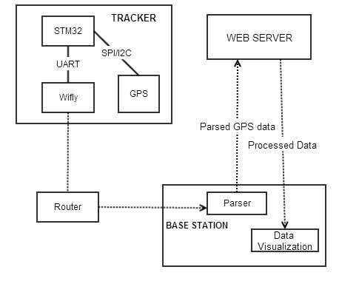

**GANNT CHART:**

